**Computer networks laboratory week 7**

**Name: Pranav R. Hegde SRN: PES1UG19CS343 Section: F1**

**Topology 1**

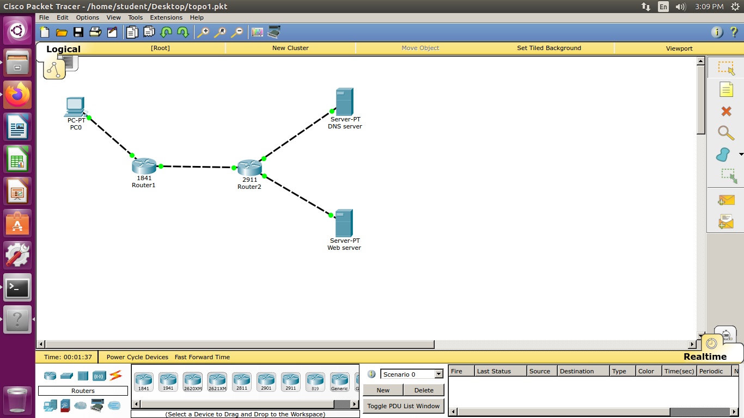

**AIM:**

* Construct a basic topology with two subnetworks joined together by two routers. One subnetwork contains a client PC. And the other contains a DNS server and a Web server.
* Send a request for a particular webpage to the Web server. And resolve DNS of a particular IP through the DNS server

**The topology:**

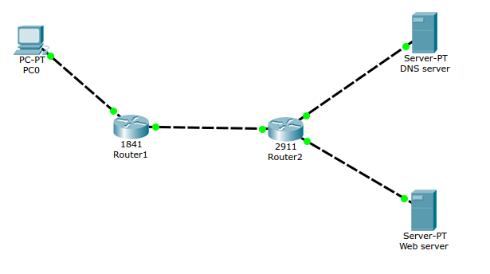

**Accessing the web page through the web server:**

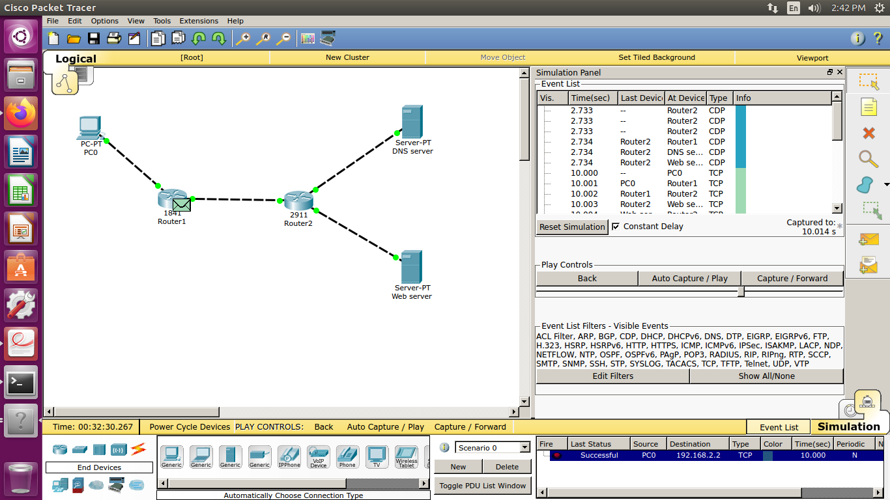

* Sending a request to access the page at 192.168.2.2 to the web server through client PC0.
* Adding a custom made web page on the web server.
* The custom made being acessed through web server.

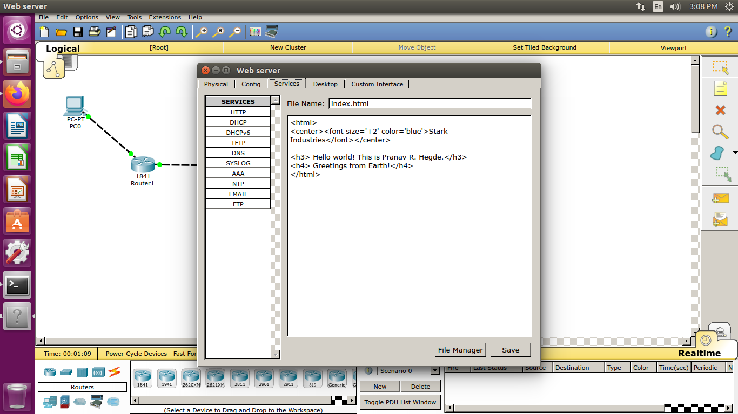

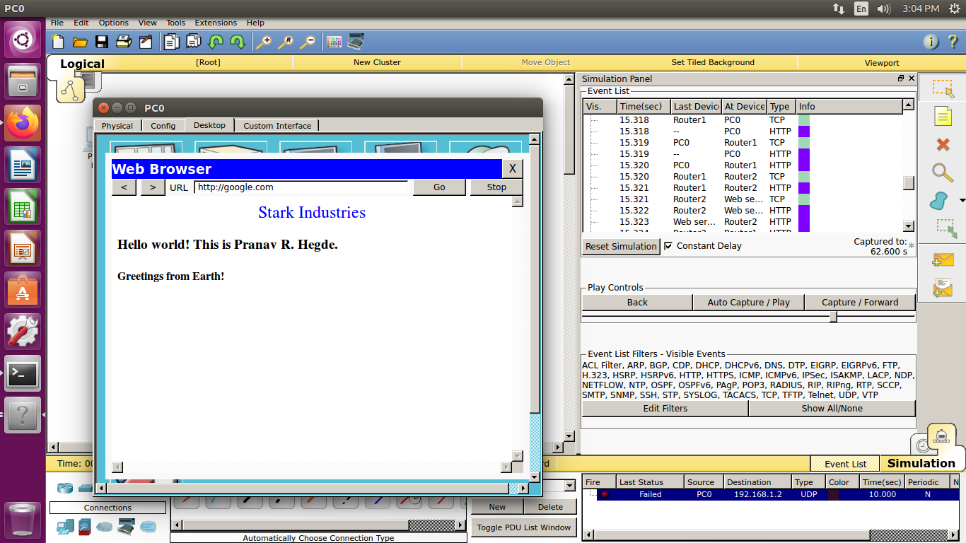

**Configuring the DNS server:**

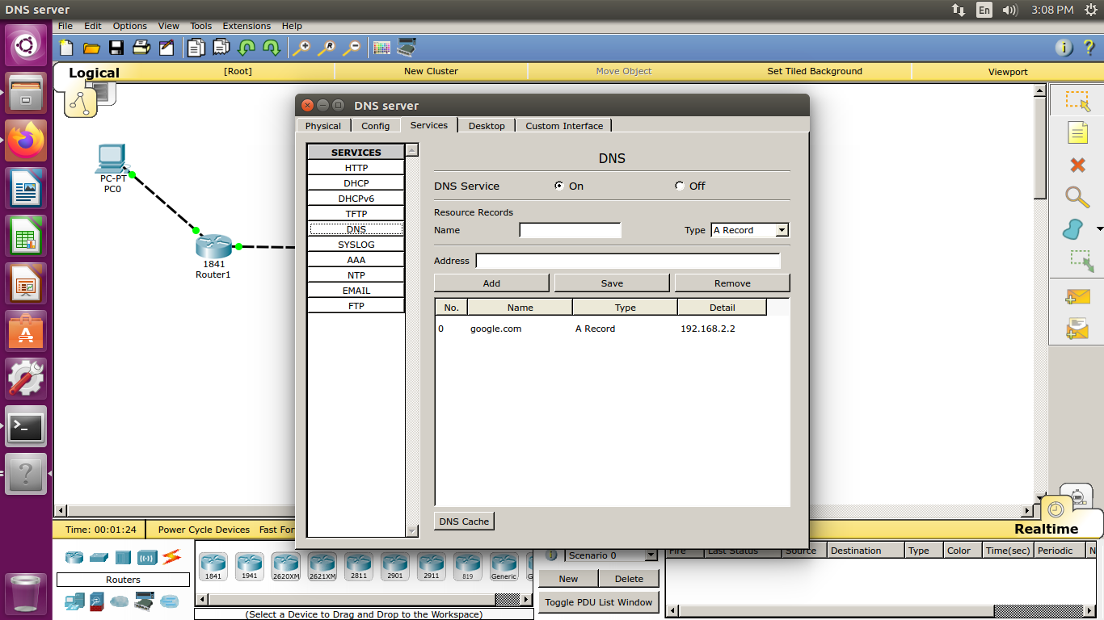

* Adding the custom made web page to the DNS server for resolution.

**Configuring the routing table:**

